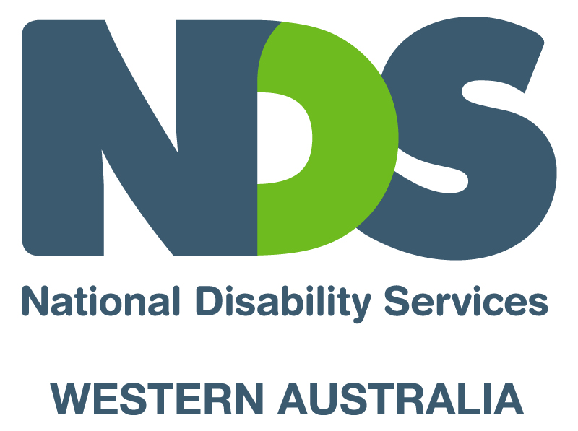

Information on accessing Workplace English Language and Literacy Program (WELL)

There have been increasing demands over the past couple of years for extra support with language and literacy skills to staff undertaking training in the disability work sector.

Some service providers in WA have already accessed WELL Funding as part of a strategy to assist support workers who need this type of extra training.

The Department of Education, Employment and Workplace Relations operates the WELL program, which assists workers to improve their English Language, literacy and numeracy skills in order to help meet their employment and training needs.
The WELL program provides assistance for the delivery of workplace-based language, literacy and numeracy training activities, as well as the development of resources that will facilitate ongoing and cost effective workplace language, literacy and numeracy training.

Below are details of how you may access further information about WELL funding from the Community Services & Health Industry Skills Council.
The Council is assisting industry to connect up with this funding by acting as a WELL broker until July 2010. In this role, the Council liaises with employers, Registered Training Organisations (RTO’s), DEEWR state offices and Indigenous organisations and works collaboratively with employers and RTO’s to progress applications and finalise funding.

Contacts:
Catherine Shirley
Industry Skills Development Manager
02 9270 6641 Mobile. 0419 200 472

Bronwyn Walker
Project Coordinator
02 9270 6635 Mobile. 0437 600 799

