Communication
Session Two
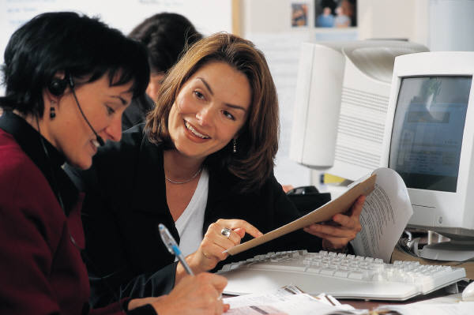

Q6. What is Communication?

_________________________________________________________

_________________________________________________________

Q7. Why is Communication important with people who have a disability?

_________________________________________________________

_________________________________________________________

What constitutes a normal communication message?
- Spoken words
- How the voice sounds
- How fast we speak
- How loud
- What we see
- Face - what our faces are saying
- How we move our body – hands, arms
- The things around us
- Pictures

Communicating with someone with a disability
Use of pictures.

Sunny

- Symbols
- Writing

How to talk with people with a disability:
- Speak to the person
- Never speak about the person as if he or she is not there
- Do not over praise when someone does something that is normal for example, 'Oh, you cook your own meals. How amazing!'
- Always respect the person's wanting to be independent (doing things for themselves). Do not help without asking first.
- Talk to people with a disability as you would any other person.

A way you can assist a person with a disability is knowing how they communicate
- Look how the person currently communicates:
  - Wants affection
  - Is upset. For example; food is taken away from them
  - Ask for things – what do they do to get things

Activity 2
Take a card out of the box provided. Team up with a partner and

communicate the information on the card, without talking.

Q8. How do we communicate with someone who can not hear?

______________________________________________________________________________________________________________________________________________________________________________
Communication – Hearing Impairment (hearing problems)
Many deaf people lip-read or use sign-language to communicate.
- If a person can not hear they will be disadvantaged by not knowing what is going on. Therefore, explain what is going on.
- use common words when providing information
- Use hand signals or write the words down
- identify yourself and ask "Can I help you?" Don't think help is always needed.
- call people who can not hear by their name so they know you are speaking to them
- do not walk away from a person who can not hear while speaking to them
- when asked a question, answer the question with a simple "Yes" or "No" or by keeping your reply brief and to the point. Wait for a response. Let them "lead" what they are talking about. Don't tell them information that they will not understand – especially when they have not asked for it.

Activity 3

L I P R E A D I N G
Aim:
To illustrate some reasons why lip-reading is difficult and consider how we can make it easier for people to lip-read us.
Team up in pairs. Ear plugs may be used. A list of sentences will be used.
Points about lip reading:
- lip reading is not easy
- a lot of guessing is involved
- most people have some ability to lip-read
- some people are better at it than others
- some people are easier to lip-read than others
- you can not lip-read unless the person talking has their mouth and face clear to see.
some words look alike on the lips, so single words are very difficult to lip read

Ways to make lip reading easier:
- the person lip reading must be looking at the person talking 
- the person's mouth, jaw and eyes must be clearly visible, that is:
- good light on face of speaker
- the person should be close and facing the lip reader
- not covered by their hands, books, cigarettes, food or other items that cover the face
- eyes not hidden behind dark glasses

- use sentences rather than single words
- give clues to what you are talking about
- speak a little slower than usual, what you are talking about and talk at a normal pace
- if you are not understood, say it another way.

Communication
Q11. How do we communicate with someone who has an Intellectual Disability?

__________________________________________________________

Communication
- Speak directly to the person with the disability.

- Make instructions clear and brief. Don’t get upset if you have to say something again.

- BE PATIENT

- Don’t be afraid to ask the person to say things again, if you don’t understand.

- Pay attention, if the person has a speech problem. Don’t complete sentences for him/her.

When speaking to people with an intellectual disability:
- speak clearly, do not mumble or turn your head away;
- do not speak like they are simple;
- use clear language - avoid long, unusual words;
- if necessary, check with the person what they have said so you understand; and
- be prepared to ask something in a different way, using different words if the person does not understand you.
In communicating with people with an acquired brain injury (from an accident or drugs) you could consider:
- writing down appointments and other information that the person may need to remember;
- offering to take the person to a location rather than giving hard directions;

- offering to provide reminder calls
Activity 4 – Provide Visual Pictures to create a story, direction or schedule appointment

Mental Illness
Communication
- Be calm
- Read the body language to assess the situation. Non verbal communication can be very helpful in times of confusion. Allow the person their space and initially avoid both direct eye contact and touching.
- Show understanding and compassion. Empathise with their feelings without necessarily agreeing with what is being said.
- Ask how you can help.
- Don’t take things personally. The person may not have insight to their behaviour and its impact to other people.
- Use short, clear and direct sentences to minimise confusion and keep your voice tone low and unhurried.

T I P S F O R G E T T I N G A LO N G

W I T H A P E R S O N W H O U S E S A W H E E L C H A I R
- do not think help is needed - ask
- accept the person's right to say no to help
- be aware of areas that wheelchairs can go to and are unable to go to. For example a place to meet may not have wheelchair ramps
- find out how to push a wheelchair, how to get up and down steps, how to tip it backwards, how to use the brake and how not to lift by the arm rests or the wheels
- try sitting or crouching down to the approximate height of people in wheelchairs or scooters when you talk to them
- do not talk about the person as if they were not present
- do not ask personal questions about the disability or its origin until you know the person well enough
- do not rush the person
- do not be sensitive about using words like "walking" or "running". People in wheelchairs use the same words.
- do not lean on a person's wheelchair unless you have their permission - it is their personal space
- do not try to move the person or their wheelchair without their permission to do so. Give a push only when asked
Exercise
Pushing a wheelchair. Look around this area and see if it is good area for people with wheelchairs. Can you get around easily.

Activity 6

S T R E S S T R I G G E R S
Aim:
To develop an understanding of the types of situations and events that can cause stress for a person with a mental illness.
Communication
- Show understanding
- Don’t take things personally. The person may not have meant what they said.


Communication
Communicating with a person with a visual impairment
- Shake hands - greet the person as you would greet anyone. Should they put out their hand it is up to you shake it.
- When speaking with a colleague who has little or no sight, introduce yourself each time until they have learned to recognise your voice. When meeting people, address them by name and always introduce yourself by name.
- The person may not be able to see you, but very aware of the the sound is coming from. Make sure that you are facing the person. Don’t look aware from the person they may think you are not interested in them.
- Say your thoughts and feelings because the person may not be able to see the non-verbal cues. Feel comfortable using words such as 'look' and 'see'. They are normal words that people who have impaired vision always use.
- When entering or leaving a room, say something that tells them you have left the room. They don’t want to be seen talking to themselves.
- Ensure that using a tape recorder or typing on a laptop is fine with them when communicating.

O V E R V I E W
What is communication?
Communication is not only passing on the message to others but also understanding the message passing on to us by others.

Communication can be either:
- easily understood by all
- specific to the person and only understood by people close to them

What constitutes a normal communication message?
Verbal – Spoken Words (7%)
Vocal – Rate and volume (38%) speed and loudness
Visual – gestures, facial expressions, body movement, objects in the environment, pictures symbols and writing (55%) What we see about the body movements.


Formats
- Audio Cassette
- Braille
- Disk
- Large and Illustrated Print
- Plain English
- Easy English
- Internet
- Radio
- Video
- National Peak Disability Bodies

Positive Communication

- The way you communicate with people with a disability has an effect on their development, self esteem and how they live.

- Become familiar with their strengths and interests; for example, for example consider what they are good at and what they enjoy

- Look for opportunities every day. In every setting, there are opportunities to build on a person’s strength and interests for example teaching new tasks at meal times such as spreading toast or making a coffee.

- Allow each person to succeed. Always encourage positive and valued behaviour.

Use of Language
A positive tone and common language are a vital part of both oral (talking) and written communication.
Here are some points to remember:
- put the person not the disability first: the correct term is 'a person with'; for example 'a person with a vision impairment' or 'people with mobility disabilities';
- avoid referring to people by categories: 'the blind', 'the disabled'. People may have similar disabilities, but they are all unique individuals;
- avoid words that put people down with disabilities. Words such as unfit, defective and incapacitated, imply inferiority;
- avoid words such as handicapped, crippled and wheelchair-bound;
- don't treat all disability groups as if they are the same.
- keep your sentences short.
Some points to consider when producing information in different mediums.
Understanding and keeping information can be done by using a range of media. Face to face communication is always the best way, but when its not possible produced material can be useful.

Print - Brochures/Factsheets etc
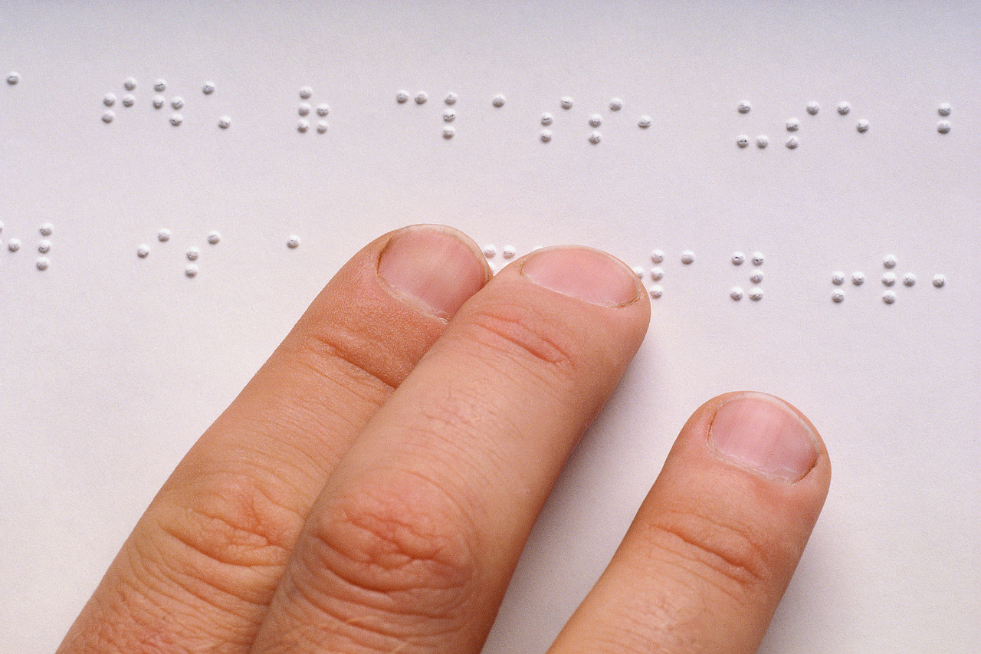
- Size of print should be 14 or 16 point minimum.
- Font should be clear and easy to read.
- Spacing is important
- Headings point out the main topic
- Short sentences are a must
- Writing in point form is clearer and easier to read.
- Pictures must match what is said. Photos must match the story
- When printing on colour paper remember that black writing on lighter colour paper is easier to read.
Posters
- A single message is all it needs.
- Bright and striking but not too busy.
- A clear picture with photos or drawings.
- Picture must match and be clear to the words and message.
- Large print, easy to read and plain language.

Video/DVD
- Video is an excellent to use.
- The video should have people that the person watching can identify.
- Ensure the stories are not long.
Audio Cassettes
- It is best they come with written booklets.
- Voices must be clear.
- The talking must not be fast.
- Keep it simple – not too much going on.

