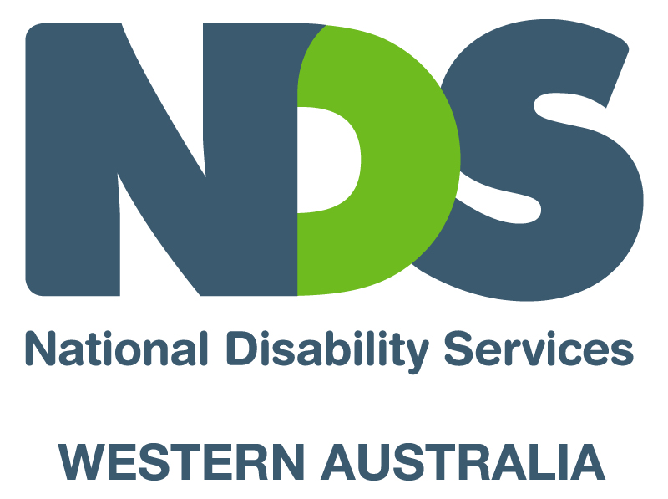

Analysis of workshop questions at the NDS/CCI Workshop 5th November 2008

There were a total of 49 participants in the workshop activity. This represented 20 different service providers.

Responses to workshop questions.

- Do you support the idea of there being an agreed set of professional competencies for all support workers in the sector?
If so, should these competencies be a qualification, or part of a qualification? If a part only, what skills are common across all service areas?

All of the 6 groups were in favour of an agreed set of competencies.
5 groups felt that this should be a full qualification; one group suggested the competencies be a part of a qualification.
4 of the groups suggested the need for an agreed set of “core” competencies across the sector, and then different electives depending upon the service model of the organisation.

Competencies identified. Those agreed by the majority of groups are in Bold italic.

Philosophy.
Social role valorisation. All 6 groups
Disability standards All 6 groups
Ethics 4 groups
Code of conduct 1 group

Communication.
Communication with colleagues/supervisors All 6 groups
Communication with service users All 6 groups
Teamwork 3 groups
Reporting/recording 3 groups
Literacy/language skills 3 groups

Medical aspects.
First aid 4 groups
Medication administration 4 groups

Personal care . 5 groups

Manual handling/manutension. 5 groups

Occupational Safety & Health. 5 groups

Behaviour Management. 4 groups

Skills Development (how to develop service user skills). 4 groups

Supporting independence/inclusion. 3 groups

Mealtime management. 2 groups (suggested as a specialist elective by one group)

Work environment skills.
Support workers role 2 groups
Workplace survival skills 1 group

Duty of care/Dignity of risk. 3 groups

- Do you support the idea of a centralised induction system for the sector, whereby several larger organisations provide an initial (sector agreed) induction training service on behalf of the sector?

All 6 groups supported the idea of an agreed, centralised induction (with some reservations)
Comments included;
There would still need to be a service provider specific induction over and above the generic induction. This would allow for specialist training.
Generic induction be a part of Certificate III qualification.
Maybe there could be 3-4 inductions delivered by specific service providers; i.e. residential, alternatives to employment, high medical support needs, co-residencies/host families.
Centralised induction would save time/money.
Specialist staff need to train and assess specialist skills.
Changes made “as a sector” to achieve consistency.
Induction reviewed every 2-3 years.
How will a centralised induction process be funded?

- What would be an appropriate title for trained para-professionals working in the sector?

This question proved to be too difficult to answer in the time allowed!
Comments included;
Title must have value to the worker’s role
Have one title across the sector
Research titles in other states/countries
Empower support workers to come up with a name
Have a competition to find a name

- If an agreed set of professional standards is to be an essential requirement for support workers, what are the benefits to the sector?

Comments included;
Better trained staff
Should lead to quality service provision
Increased value of workers
Increased value of sector
Job satisfaction for support workers
A career path for workers
A more “professional workforce
Will save resources
Will improve retention of staff
Will reduce supervisor stress
More consistency across sector
Will promote co-operation between service providers
Portability of skills between service providers
Reduced OH&S risks

- Is there a need for a systematic professional development strategy whereby existing support worker staff undertake “refresher” training? If so, what should the training cover, and how frequently should training occur?

Whilst all groups agreed that on going training was needed for support workers, there were differences in “how best” to do this.

Comments included;
Should not be systematic, but on a needs basis; i.e. ongoing performance management process that identifies training needs.
Staff’s skills should be reviewed annually.
Existing staff should do refresher training every 2-3 years.
Suggested training topics.
Motivational training
Personal care skills
Mealtime management
Medication administration
Time management
Opportunities for training for staff wanting to move into senior positions

- Are there specialist skills over and above those covered by national qualifications, that are essential to some providers? How are these skills best trained and assessed?

Not all groups were able to address this question in the time provided.

Comments included.
Different models of service provision
How to de brief after an incident
Conflict resolution
Counselling skills
Specialist skills must be trained by “specialists” not “generic trainers”

- Any other comments/observations?

Limited responses again due to time.

Staff transferring to service providers within the sector should be able to carry over entitlements.
Induction should go over 3 months.

Where to from here?

The feedback provided from the workshop will be taken to the reference group, and I will suggest that the group identify some recommendations for strategies to address the workshop’s responses.
I will provide the workshop’s responses to training providers as a starting point for discussions with them.
I will take the responses to the regional and remote service providers meeting next week. It will be interesting to hear their thoughts.
I would encourage you to maintain your interest in support worker training by talking to colleagues at work, and maintaining contact with a “service provider” reference group member i.e.
Charlotte Howell charlotteh@hcsg.com.au
Leanne Parsons leanne.parsons@myplace.org.au
Shane Mauger shane.mauger@identitywa.com.au
Rob Holmes rob@sfswa.org.au
Jacqueline McGregor Jacqueline.mcgregor@dsc.wa.gov.au

I would also be happy for people to call or email me with their ongoing thoughts about the future of support worker training. david.rogers@nds.org.au 9208 9815.

It is my intention to provide regular email updates on the progress of the support worker training project during the next 12 months.

Thanks again to the 49 participants at the workshop, and thanks to Michelle Etulle (Diploma in Community Welfare student) for helping with the above analysis.

David Rogers

